***1NT19IS135***

***SAHANA V***

***C1 BATCH***

* ***PIPELINE AGGREGATE FUNCTIONS***

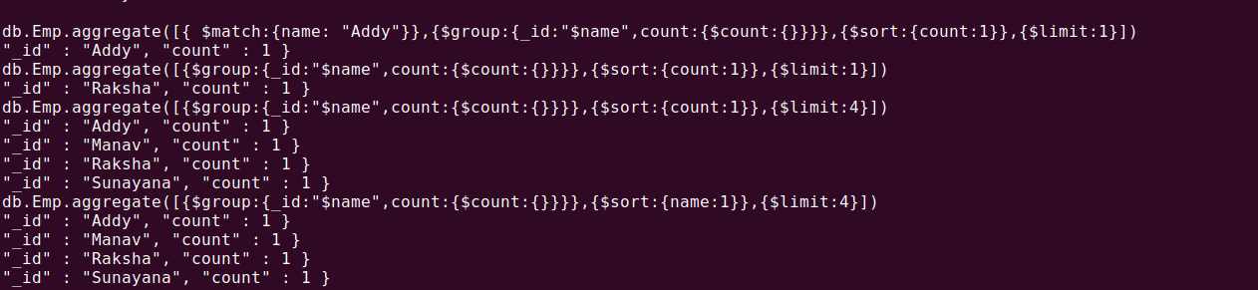

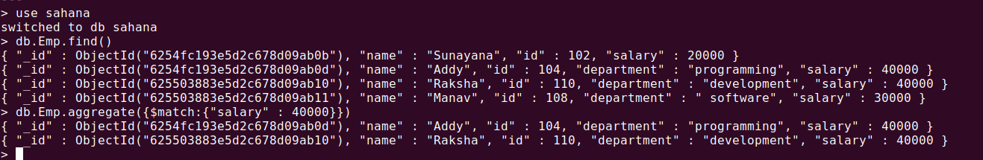

***$MATCH operation*** :



***$PROJECT operation:***

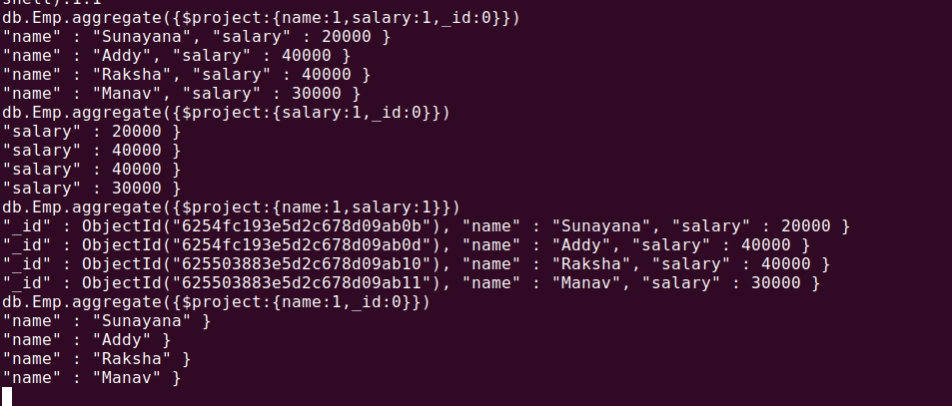

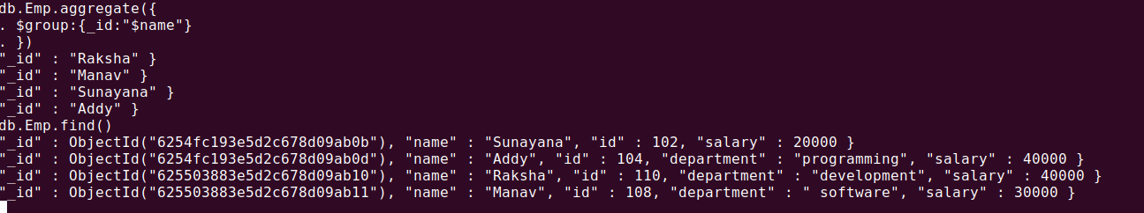

***GROUP BY:***

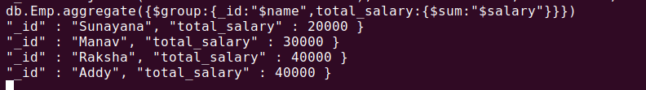

***FIRST SALARY***

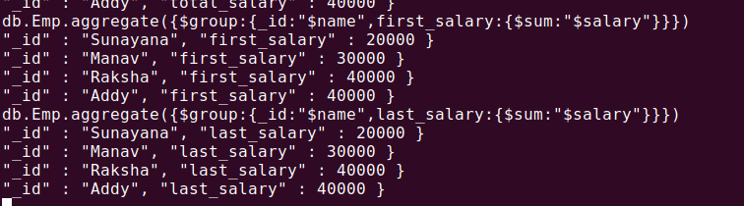

***MAX SALARY***

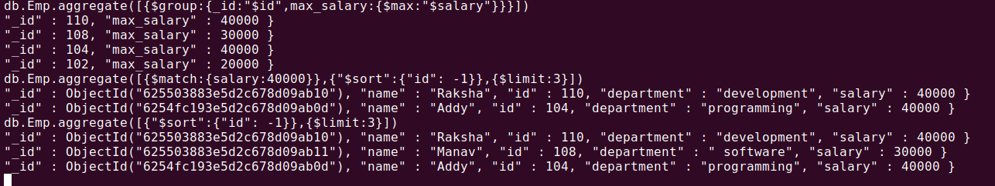

***MIN SALARY:***

***AVG SALARY:***

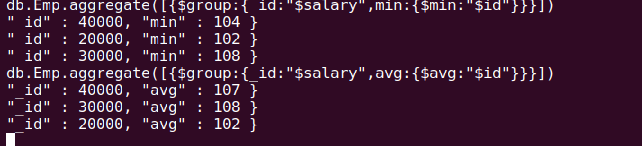

***$SORT:***



***GROUP BY MAX SALARY***

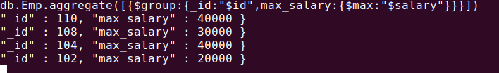

***MAP FUNCTION : taking 2 same names and those 2 names have different salaries after mapping them with sum operation salary will get combined.***

